Ideation Phase
Empathize & Discover

Date | 31 January 2025
Team ID | LTVIP2026TMIDS42870
Project Name | electric motor temperature prediction using machine learning
Maximum Marks | 4 Marks

Empathy Map Canvas:
An empathy map is a simple, easy-to-digest visual that captures knowledge about a user’s behaviours and attitudes.

Primary User:
Industrial Maintenance Engineer / Reliability Engineer
Secondary User:
Plant Operations Manager
Example:
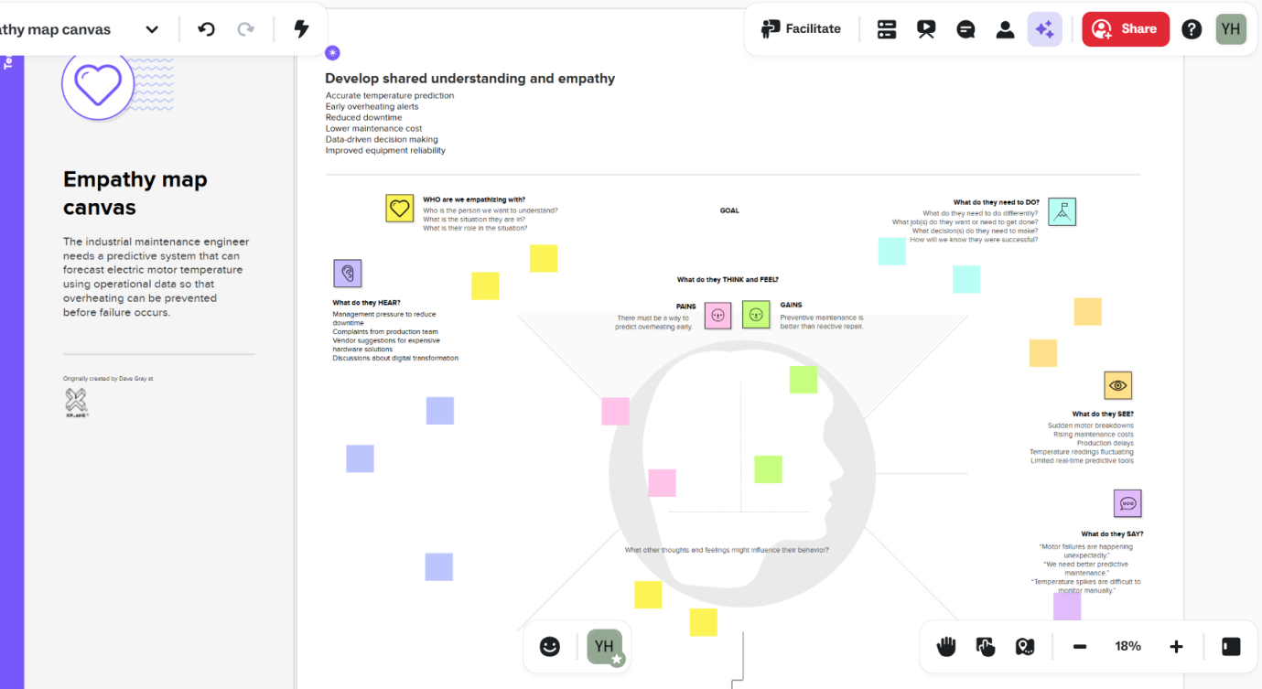

Reference: Empathy map canvas • Yaswanth Hari

